# BHARATI VIDYAPEETH (DEEMED TO BE UNIVERSITY),

**COLLEGE OF ENGINEERING,**

**PUNE-411043**

## Department of Information Technology



**A**

**Project Based Learning On**

**“ Dual Axis Solar Tracker System”**

**Submitted By**

|  |  |
| --- | --- |
| PRN No. | Name |
| 2414111034 | Rahul Kumar |

**Under the Guidance of**

## Prof. Prakash Devale

**DEPARTMENT OF INFORMATION TECHNOLOGY**



# Certificate

This is to certify that the work under Project Based Learning (PBL) for the topic **“Dual Axis Solar Tracker System”** is carried out by Rahul Kumarunder the guidance of **Prof. Prakash Devale** in partial fulfillment of the requirement for the degree of **Bachelor of Technology in Information Technology Semester-III** of **Bharati Vidyapeeth (Deemed to be University), Pune**  during the academic year **2024-2025**.

## Date:- 15|10|2024 Prof. Prakash Devale GUIDE

### ACKNOWLEDGEMENT

We would like to express deepest appreciation towards Dr Vidula Sohoni, Principal, Bharati Vidyapeeth (Deemed to Be University) College of Engineering, Pune, India and Dr.Sandeep Vanjale Head of the Department (IT), who invaluable supported us in completing this project.

We are profoundly grateful to Prof. Prakash Devale, Project guide for her expert guidance and continuous encouragement throughout to see that this project rights, its target since its commencement to its completion.

At last we must express our sincere heartfelt gratitude to all the staff members of IT Department who helped us directly or indirectly during this course of work.

**Rahul kumar**

**B.Tech. (IT) Semester – III**

**INDEX**

|  |  |  |
| --- | --- | --- |
| Sr. No. | Title | Page No. |
| 1. | Introduction | 4 |
| 2. | Circuit Diagram | 5 |
| 3. | Components & Software Used | 6 |
| 4. | Execution Steps | 7 |
| 5. | Application | 8 |
| 6. | Conclusion | 10 |

**INTRODUCTION**

The dual-axis solar tracker project aims to optimize solar energy capture by adjusting the orientation of solar panels to follow the sun’s trajectory throughout the day. This innovation enhances energy efficiency compared to fixed solar panels, leading to higher energy production and improved sustainability in energy generation. By utilizing light-dependent resistors (LDRs) to detect sunlight, this system continuously aligns the solar panel to maximize light absorption.

**Project Overview and Key Features**

The dual-axis solar tracker utilizes servo motors to move the solar panel both horizontally and vertically, ensuring it remains in the optimal position for sunlight exposure. Key features of the project include:

* **Increased Energy Efficiency:** Up to 25-50% more energy capture compared to static solar panels.
* **Dynamic Movement:** Continuous adjustment based on real-time light intensity readings.
* **Self-Cleaning Mechanism:** Reduced manual maintenance by leveraging rainwater for panel cleaning.
* **Remote Monitoring:** Integration with IoT for monitoring and controlling the system via a mobile application.

**CIRCUIT DIAGRAM**

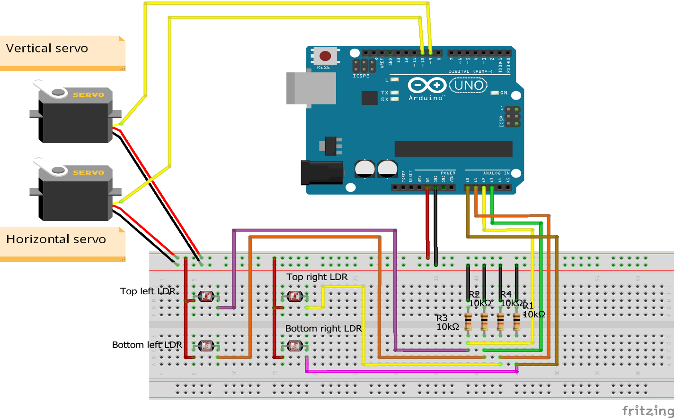

The circuit diagram for the dual-axis solar tracker system provides a visual representation of the connections and functionalities of various components in the setup. This diagram is crucial for understanding how the system operates as a whole.

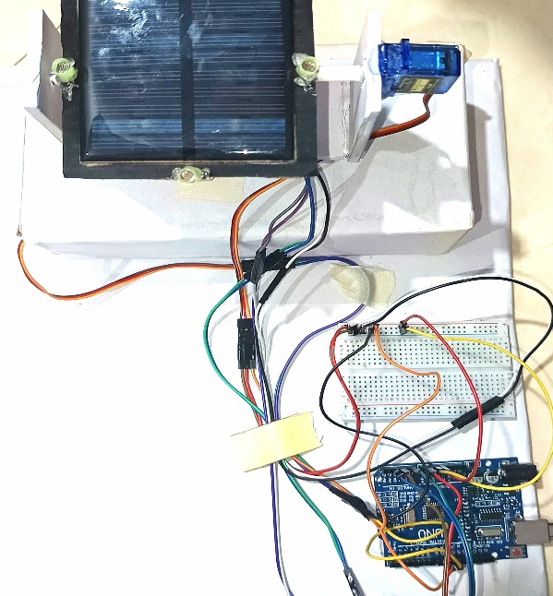 picture of model

**Component and Software Used:**

**Components Used**

* **Arduino Uno:** The microcontroller that coordinates the system's operations.
* **Servo Motors:** Responsible for rotating the solar panel along both horizontal and vertical axes.
* **Light-Dependent Resistors (LDRs):** Detect sunlight intensity to determine the sun’s position.
* **Resistors:** Used with LDRs to create a voltage divider, ensuring accurate readings.
* **Jumper Wires:** Connect various components, allowing for flexible circuit assembly.

**Software Used**

* **Arduino IDE**: The integrated development environment for programming the Arduino microcontroller, enabling the implementation of control algorithms and data processing**.**



Picture of Arduino Ide

**Execution Steps (Steps/procedure of working method):**

1. **Initialization:**Configure Arduino pins for LDRs and servo motors, establishing communication channels.
2. **LDR Readings:**Continuously read light intensity values from the LDRs to determine the position of the energy source.
3. **Angle Calculations:**Calculate the angles for the servo motors based on LDR data to maximize sunlight absorption.
4. **Servo Control:**Rotate the solar panel to the calculated angles using the servo motors.
5. **Continuous Adjustment:**Implement a loop to regularly read LDR data, recalculate angles, and adjust the panel’s orientation throughout the day.

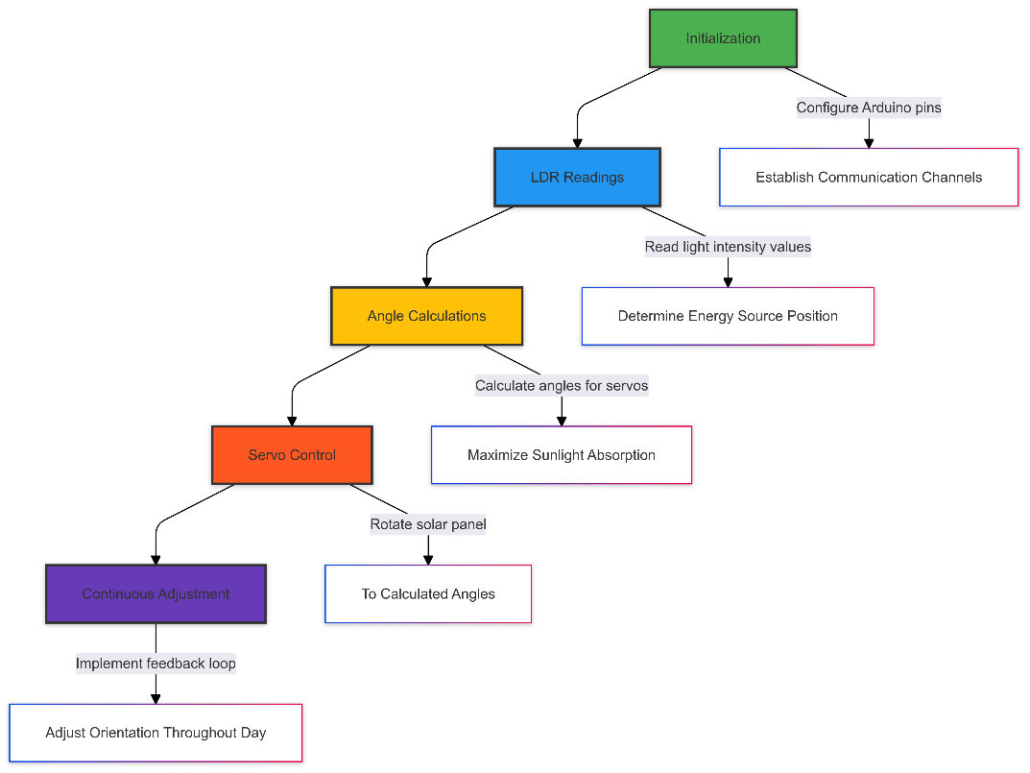

**flowchart**

**Applications:**

1. **Residential Solar Energy Systems:**  
   Enhancing home energy efficiency through improved solar panel orientation.
2. **Commercial Solar Installations:**  
   Increasing energy output for businesses using solar energy.
3. **Remote Monitoring Systems:**  
   Enabling remote tracking and management of solar panel performance.
4. **Research and Development:**  
   Providing a platform for studying solar tracking technologies and their impacts on energy production.
5. **Agricultural Applications:**  
   Powering irrigation systems and farm equipment with optimized solar energy collection.

**Future Enhancement:**

1. **Smart Technology Integration:**  
   Implement IoT devices for remote monitoring and control, enabling real-time data analysis and diagnostics to optimize system performance.
2. **AI-Powered Optimization:**  
   Use artificial intelligence to predict sunlight patterns, dynamically adjusting the solar panels for maximum efficiency and energy yield.
3. **Energy Storage Solutions:**  
   Incorporate advanced battery systems to store surplus energy generated during peak sunlight, ensuring availability during low sunlight or nighttime.
4. **Modular Scalability:**  
   Design flexible, modular systems that allow easy expansion, enabling users to integrate more solar panels or other renewable energy sources as needed.
5. **Weather Adaptability:**  
   Install environmental sensors that can adjust the panel’s orientation based on weather conditions like wind or heavy rain, enhancing durability and operational efficiency.
6. **User-Friendly Interface:**  
   Develop a mobile application that provides real-time performance monitoring, system alerts, and remote control features, making system management more accessible for users.

**Conclusion:**

The dual-axis solar tracker system project demonstrates a significant improvement in solar energy efficiency by ensuring optimal alignment of solar panels with the energy source throughout the day. By utilizing light-dependent resistors (LDRs) and servo motors controlled by an Arduino, the system continuously adjusts the solar panel's orientation to capture the maximum possible energy. This not only increases energy output but also contributes to sustainable power generation with minimal human intervention.

Furthermore, with future enhancements like AI-based optimization, IoT integration, and energy storage solutions, this project has the potential to evolve into a highly efficient, automated, and scalable system. The combination of smart technology and renewable energy solutions makes this a valuable contribution towards reducing the carbon footprint and increasing the adoption of clean energy in residential, commercial, and industrial applications.

In conclusion, this project not only highlights the potential of solar tracking systems but also paves the way for future innovations in renewable energy technology.

**References**

1. Arduino Uno Rev3. Retrieved from <https://store.arduino.cc/products/arduino-uno-rev3>
2. Deepthi, S., Ponni, A., Ranjitha, R., & Dhanabal, R. (2013). Comparison of Efficiencies of Single-Axis Tracking System and Dual-Axis Tracking System with Fixed Mount. International Journal of Engineering Science and Innovative Technology, 2(2), 425-430.

[link:](https://www.ijesit.com/Volume%202/Issue%202/IJESIT201302_66.pdf)

1. Barker, L., Neber, M., & Lee, H. (2013). Design of a low-profile two-axis solar tracker. Solar Energy, 97, 569-576.

[www.researchgate.net/publication](https://www.researchgate.net/publication/270954262_Design_of_a_low-profile_two-axis_solar_tracker)

1. GitHub Arduino-Solar-Tracker. Retrieved from <https://github.com/topics/arduino-solar-tracker>
2. Instructables. (n.d.). Arduino Solar Tracker. Retrieved from <https://www.instructables.com/Arduino-Solar-Tracker/>